1. **Structure of Web Browser**

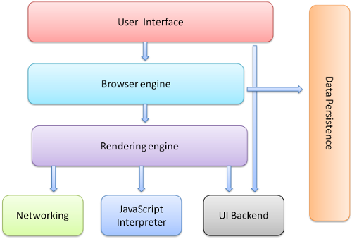

## *Image 1.1: Basic Structure of Web Browser*

# 1.1 User Interface:

This includes the address bar, back/forward button, bookmarking menu, etc. Every part of the browser display except the window where you see the requested page.

# 1.2 The browser engine:

Performing actions between the UI and the rendering engine.

# 1.3 The Rendering engine:

Responsible for displaying requested content. For example, if the requested content is HTML, the rendering engine parses HTML and CSS, and displays the parsed content on the screen.

# 1.4 Networking:

For network calls such as HTTP requests, using different implementations for different platform behind a platform-independent interface.

# 1.5 UI backend:

Used for drawing basic widgets like combo boxes and windows. This backend exposes a generic interface that is not platform specific.

# 1.6 JavaScript interpreter:

Used to compile and execute JavaScript code.

# 1.7 Data storage:

The browser may need to save all sorts of data locally, such as cookies.